Experiment # 1

Lab Title: | Introduction to MIPS assembly language
Learning Objectives: | To use PCSpim simulator for simulation of MIPS assembly language program
Tools used: | PCSpim
Procedure:
Assembly Language:
Instructions used by any processor are actually a mere sequence of bits. When we have to write a program for processor, we have to use these bit sequences. This approach is not only time taking but also prone to errors.
A useful alternative is to write program for a processor in assembly language. Assembly language is different for each processor because it is representation of instruction set of processor in terms of symbols.
Assembly language provides the advantage of exploiting the hardware more efficiently than higher level languages.
Following is an example of MIPS add immediate instruction.

addi $8, $0, 4

Where $8, $0 are MIPS internal registers and 4 is immediate value.
Format for this instruction is
Op | rs | rt | Constant
6 bits 5 bits 5bits 16 bits

Format of add and sub instructions is
Op | rs | Rt | rd | shamt | funct
6 bits 5 bits 5 bits 5 bits 5 bits 6 bits

op: basic operation Opcode
rs : first register source operand
rt: second register source operand
rd: register destination operand
shamt: shift amount (for shift instructions)
funct: Function specific variant of the operation [Op]

PCSpim:
To use PCSpim as an assembly language simulator follow these steps.

Step 1: Write your assembly language program in notepad and save it as an assembly file with extension .asm

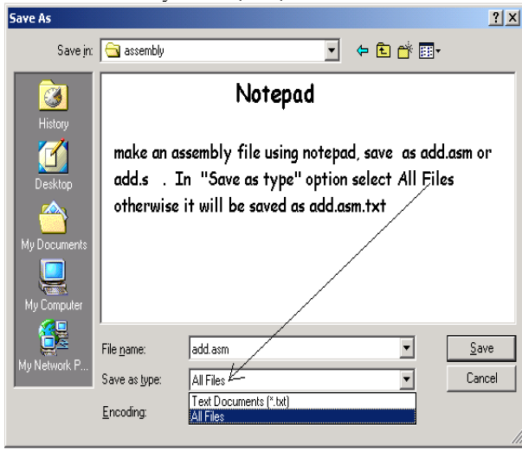

Fig 01.1: saving assembly file

Step 2: To open PCSpim follow the path
StartPCSpim

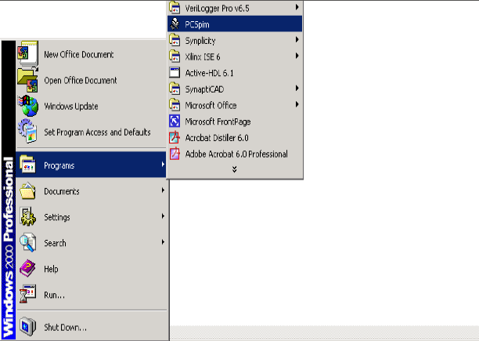

Fig 01.2: Opening PCSpim

Step 3: Now you will see a window labeled “PCSpim” on you desktop.
Various portions of this screen are shown in following snapshot.

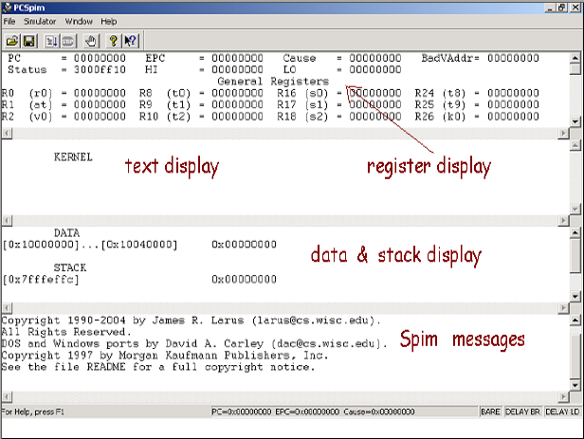
Fig 01.3: PCSpim Window
Register Display: This portion shows the contents (bit pattern in hex) of all 32 bit general purpose registers and a few others.

Text Display: This shows the assembly language program source, the machine instruction (bit pattern in hex) they correspond to, and address of their memory locations.

Data and Stack Display: This shows the section of MIPS memory that hold ordinary data and data which has been pushed onto stack.

SPIM Messages: This shows messages from simulator (often error messages).

Step 4: To simulate the assembly file you have saved, first select settings of simulator. To do this follow the path given below.

SimulatorSettings

Select the options as shown in following snapshot.

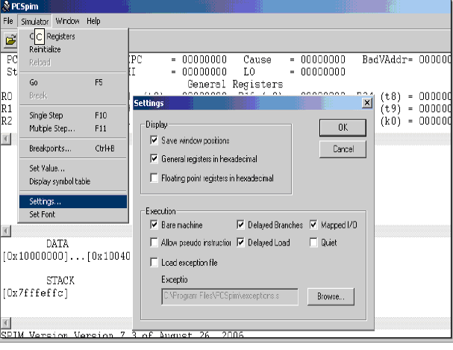
Fig 01.4: Simulating assembly file

Step 5: Now open your assembly file by following the path shown below.

FileOpen

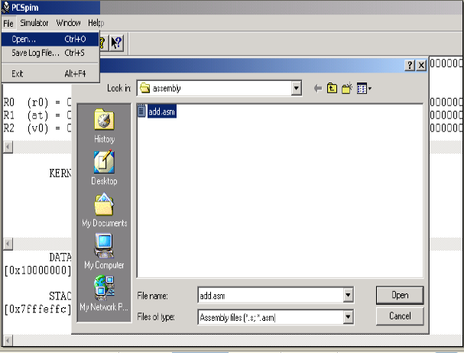

Fig 01.5: Opening File

Step 6: Let the program following is the assembly program saved by you in your assembly file.

addi $s0, $0, 4 //load 4 to $0

addi $s1, $0, oxa //load 10 to $1

add $s2, $s0, $s1 //$s2=$s0+$s1

Now, when you open your file in PCSpim it appears as in following snapshot.
Observe that in register Display portion, PC, s0, s1, s2 all registers are initially cleared. Text display panel contains not only your assembly program but also hex code of instructions and addresses of their memory locations. Data Display shows no data initially. SPIM Message panel shows that your program has been loaded successfully.

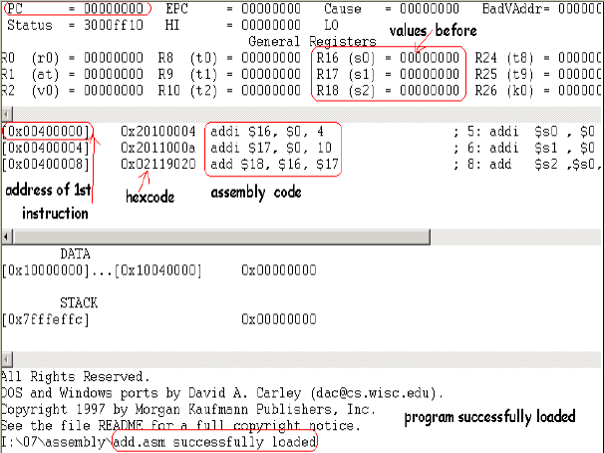

Fig 01.6: Simulation Results.

Step 7: After successfully loading your file, now you have to simulate your program. For this purpose first copy the address of first instruction from text display and then press F5 or follow the path shown below.

SimulatorGo

You will see a run parameter dialog box. Paste the address in field labeled “Starting address” and click Ok.

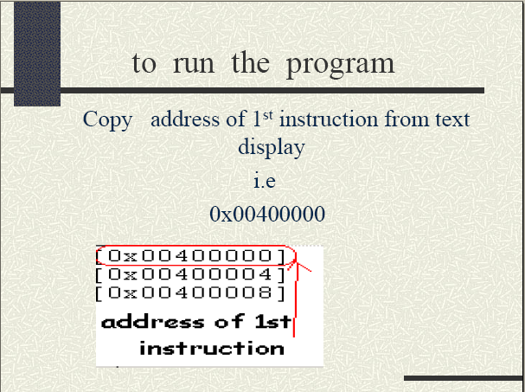

Fig 01.7: Setting the starting address

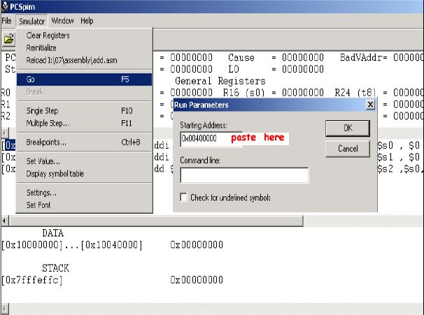

Fig 01.8: Setting the starting address

Step 8: Now in main window of PCSpim you can see following changes.
- In register Display panel, s1, s2, s3 are loaded with your desired values.
- SPIM Message panel carries following message.
“Attempt to execute non_instruction at 0x004000C”
Because there was no instruction in memory at above mentioned address.

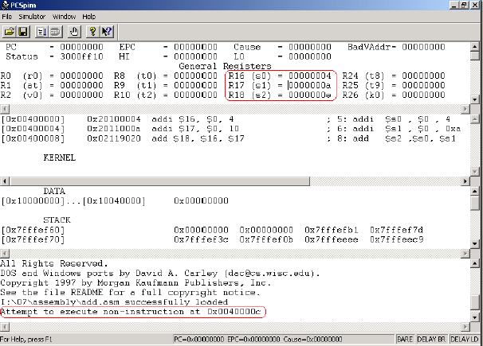

Fig 01.9: Observing output

NOTE: Go (F5) commands runs the whole assembly language program while single stepping (F10) executes single instruction at a time.

Exercises:
Complete following tasks in Lab.

1 Convert the following C code into MIPS assembly language. Use appropriate registers for the variables.

m = (a - c) + (d + e)

Get the Hex code from PCSpim for each instruction. Convert hexcode of at least three instructions into binary using PC Calculator (type CALC at Start->run) .
Separate the different fields of these MIPS instructions according to their format and Write Decimal values.
2 Make an assembly file (let logical_operations.asm) and write MIPS assembly language program to perform AND, OR, XOR on the following numbers using PCSpim.

0xf f f f f f f f
0xf 0 f 0 f 0 f 0
Lab performed on (date): ___________ Signature: ______________
Checked by: ________________________ Date: ______________
Marks Awarded: ____________
Comments:

